Lab 06: Deciphering File Formats

CYBR 688: Software Reverse Engineering

Team Members: Sairam Bokka, Ethan Hart

Introduction:
In this lab, we will analyze a simple multiplayer maze game implemented in a client-server model to understand undocumented data formats (file formats, protocols, compression algorithms, etc.). We will document the protocol and/or provide software artifacts that could help a developer write an application that communicates via that protocol. We will also write a custom client to communicate with the server providing a computerized player.

Understanding the Rules of the Game:
This is a fairly simple multiplayer maze game implemented in a client-server model. The server is a dedicated server and implements the rules of the game. Each player uses a client to communicate with the server and participate in the game.
The goal is to be the first player to reach the exit of the maze. The starting position is the top-left space, and the finish is always the bottom-right space. No two players may occupy the same space at the same time. Thus, at the beginning of the game, higher-numbered players are placed to the right of the lower-numbered players. This may seem to create an unfair advantage, but it is possible for players to jump.
Each player is given 3 jumps. Jumps may be used to pass over a wall and/or move past another player. Jumping to a space outside the maze boundary is not allowed. Jumping where there is neither a wall nor another player is not allowed. Walking through a wall or another player is not allowed. If you attempt an illegal move, you lose that turn. Attempting to jump a fourth time does not cause you to lose your turn.
Issue movement commands by typing one of W, A, S, or D when it is your turn. Lower case values indicate walking. Upper case values indicate jumping. An upper-case L or Ctrl-C will leave the game.
Players may enter and leave the game at will. When a player enters or re-enters, the token is placed in the top-left space, or an unoccupied space to its right.
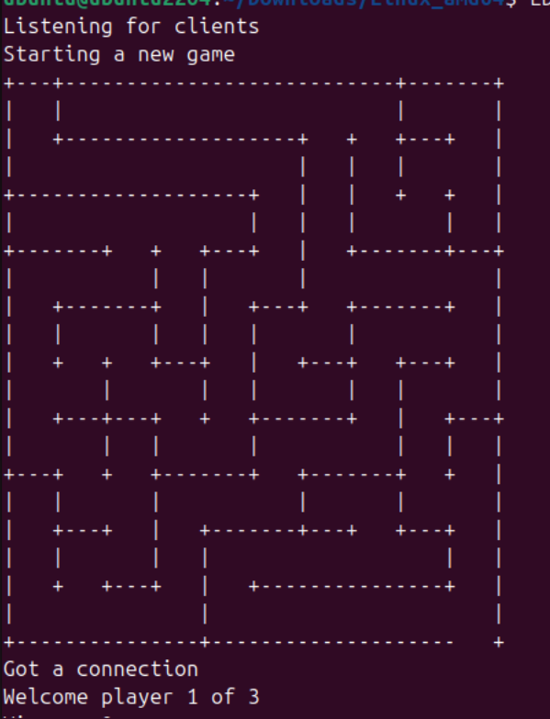
Figure 1: Multiplayer Game Server
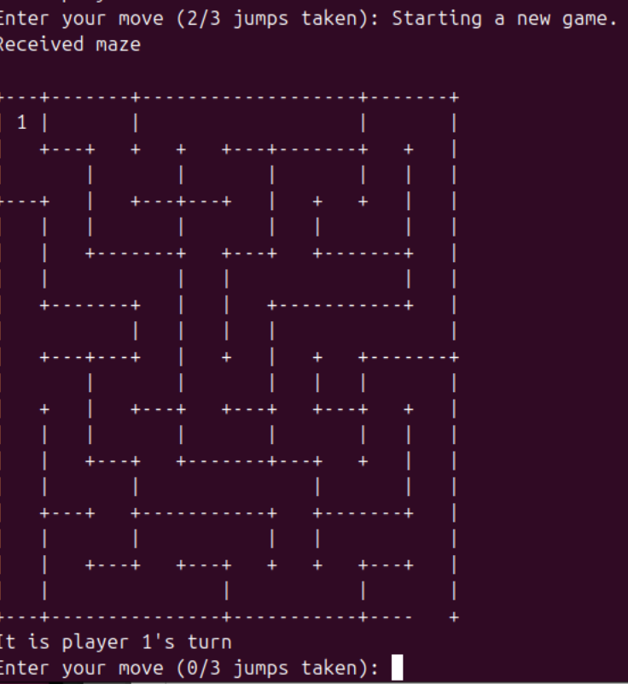
Figure 2: Multiplayer Game Client
Reverse Engineering:
- We will start this section by capturing the network capture going back and forth from client and server using wireshark. We start wireshark in loopback mode and capture the network packets for the initialization of both client and server.
- Once we connect client to server, we have captured some network packets from client to server and vice versa. The server is listening to client on port 8008.

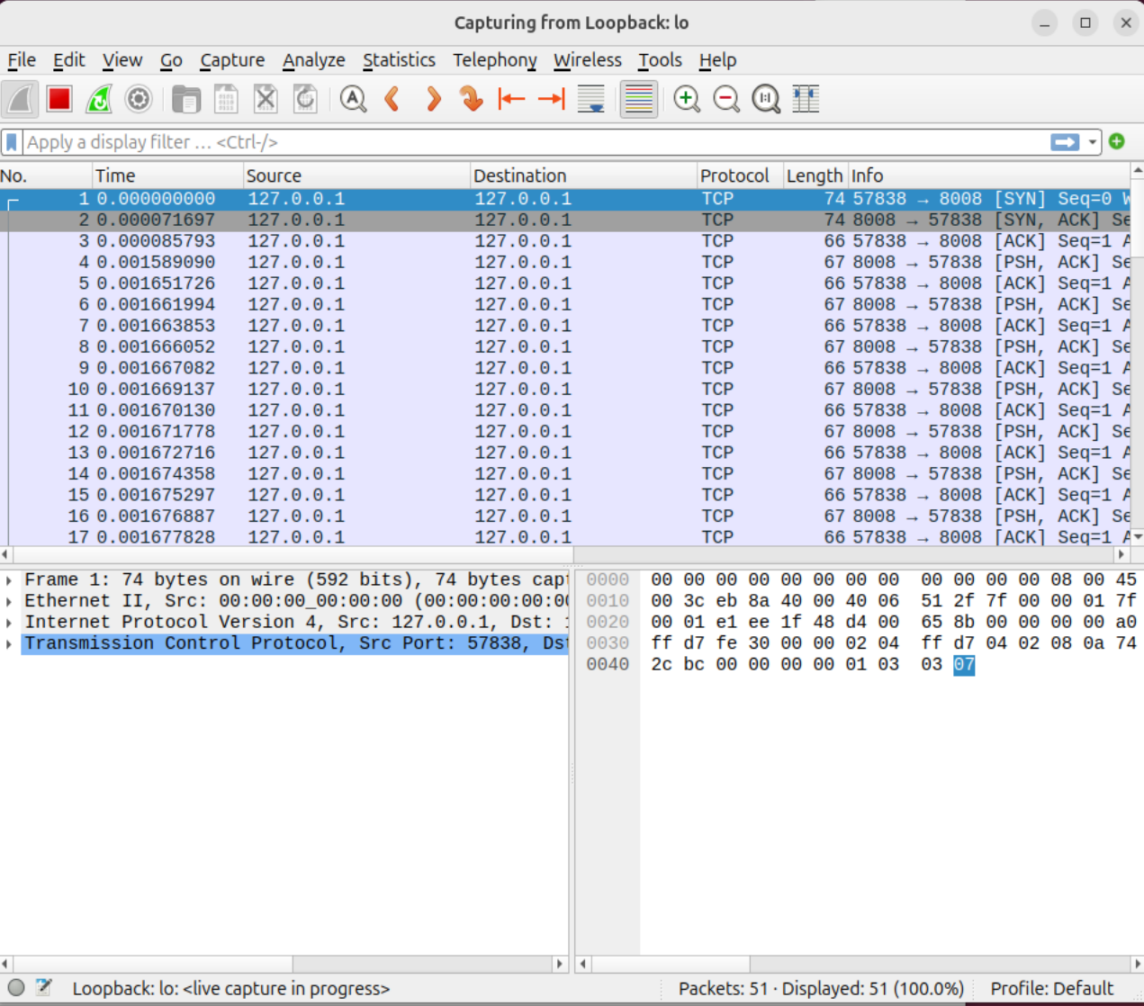

- We can follow the TCP stream from client to server to see the communication made between client and server. This is a hex dump, where we can see that server is not sending anything to client in plain text.
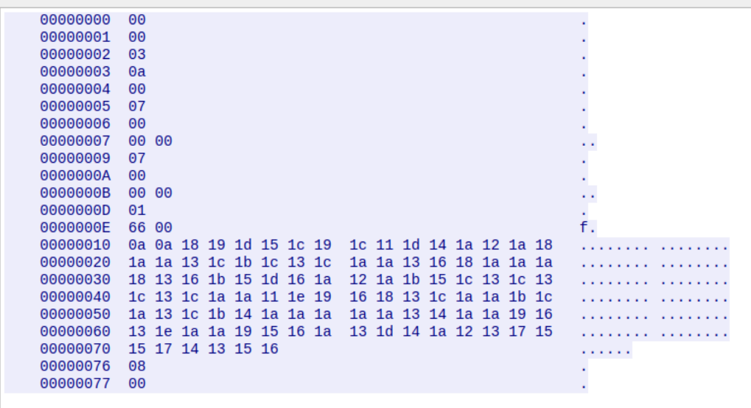

- We will setup our own socket using python and try sending the hexadecimal data, trying to see what part of the stream initializes the client and decode the hex.
- After setting up a socket with client, we analyze messages of client and decode the hex stream one-by-one. There are some silent messages which can be decoded by static analysis of client using ghidra. The basic structure of the initialization is as follows:

Byte Sequence Documentation
This documentation explains the byte sequence, which appears to be for a game setup where players join, and messages and game states are initialized, specifically for a multi-player maze game setup.
Key
- Byte Offset: Shows the position in the file.
- Hex Value: The actual data in hexadecimal format.
- Description: Explanation of what each byte or group of bytes represents.
Breakdown

0x00000000 - 0x00000002: Welcome Message
- 0x00000000 - 0x00000001: 00 00
  - Indicates the beginning of the welcome message sequence for Player 1.
- 0x00000002: 03
  - Specifies the total number of players (3 players).
  - Interpretation: 00 is Player 1, and 03 is the total players.
Message: "Welcome Player 1 of 3" (based on the first three bytes)

0x00000003 - 0x00000004: Player Join Message
- 0x00000003: 0a
  - Indicates a player has joined.
- 0x00000004: 00
  - Specifies Player 1 (encoded as 00).
Message: "Player 1 has joined"

0x00000005 - 0x00000007: Player Position Information
- 0x00000005: 07
  - Likely denotes a command related to player position or status update.
- 0x00000006 - 0x00000007: 00 00
  - Could represent a column and row position or a status indicator for Player 1 in the game grid (exact usage may vary depending on the game engine).

0x00000009 - 0x0000000B: Repeated Position Information
- 0x00000009: 07
  - Repeats command 07 seen earlier, potentially for another positional update.
- 0x0000000A - 0x0000000B: 00 00
  - Repeated 00 00 could signify the starting or reset position of a player.

0x0000000D - 0x00000077: Maze Data
This sequence represents a compressed or encoded maze layout and possibly character movements.
- 0x0000000D: 01
  - Likely a command or identifier for the start of maze data.
- 0x0000000E - 0x00000077: 66 00 0a 0a 18 18 19 15 ... 12
  - A long sequence of bytes appears to be encoded maze data, where each byte likely represents a cell in the maze with unique attributes.
  - 0a, 0a at the start represent size of the maze(10x10 in this case).
  - Values like 18, 1c, etc., could represent walls, open paths, or special points of interest within the maze.
Interpretation: Maze layout data where each byte might encode specific features or types of tiles.

0x00000076 - 0x00000077: Maze Command or End Marker
- 0x00000076: 08
  - Potentially a command to finalize or print the maze layout.
- 0x00000077: 00
  - Could signify the end of data or reset the state for the maze output.

- Looking at the decompiled code in ghidra, it is quite clear that each and every scenario has it’s own case which are represented by byte values.
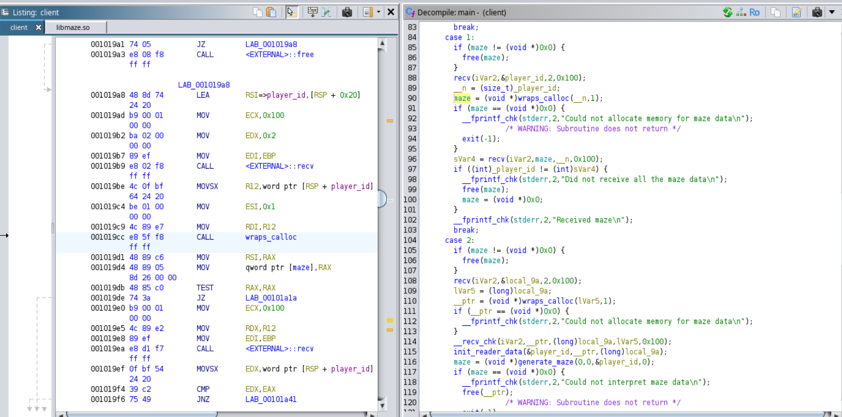

- Each case represents a set of messages in the byte stream sent by server to client, which is handled by client based on the state of client.
The cases that we need to handle moves sent by client are as follows:
- MSG_WELCOME = 0 handles welcome message which receives:
        - 1 byte: my_player_id — The player's ID.
        - 1 byte: max_players — The total number of players in the game.
- MSG_MAZE_DATA = 1 handles maze data which receives:
        - 2 bytes: size — The size of the maze data (often ignored but can denote total size of remaining data).
        - 1 byte: col_count — Number of columns in the maze.
        - 1 byte: row_count — Number of rows in the maze.
- MSG_ILLEGAL_MOVE = 5 handles illegal moves
- MSG_NOT_YOUR_TURN = 6 handles incorrect turns
- MSG_PLAYER_POS = 7 handles player position which receives:
        - 1 byte: player_id — The ID of the player whose position is updated.
        - 1 byte: col — The player's new column position.
        - 1 byte: row — The player's new row position.
- MSG_PLAYER_TURN = 8 handles player turn (Opponent vs itself) which receives:
        - 1 byte: player_id — The ID of the player whose turn it is.
- MSG_PLAYER_JOINED = 10 handles if a new player has joined which receives:
        - 1 byte: player_id — The ID of the player who joined.
- MSG_PLAYER_LEFT = 11 handles if a player left the server which receives:
        - 1 byte: player_id — The ID of the player who left.
- MSG_PLAYER_WINS = 12 handles if we win which receives:
        - 1 byte: player_id — The ID of the player who won the game.
- MSG_NEW_GAME = 13 handles a new game message

- We create a client with python, which will handle these cases and respond to the server with valid moves. The client will prioritize moving to the bottom left from the start place and try moves until it wins or loses.
Conclusion:
We successfully documented and reverse engineered a client-server multiplayer protocol and created a bot which will attempt to win the game using least amount of moves against an opponent.

